

**PALO ALTO SPEEDOMETER, INC.**

**718 Emerson St Palo Alto, CA 94301-2410**

**Phone: (650) 323-0243 Fax: (650) 323-4632**

**info@paspeedo.com**

**www.paspeedo.com**

**Terminology and Options Sheet**

* **Full Concours Level Restoration**
  + This job entails a few things that will make the gauges look ready for their next car show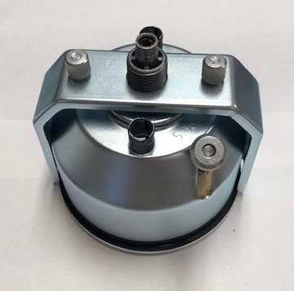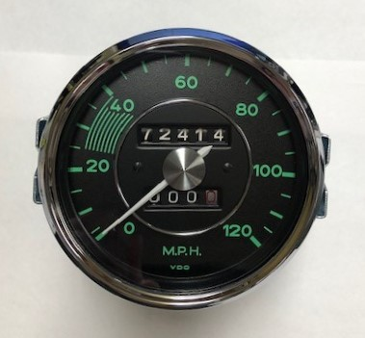
    - The case will be zinc’d, painted white on the inside, brim wiped.
    - The guts of the gauges will be recalibrated and/or repaired.
      * If a gauge movement or coil is unrepairable, it will be replaced with a new one that can be made to be 6 or 12 volt depending on your vehicle. 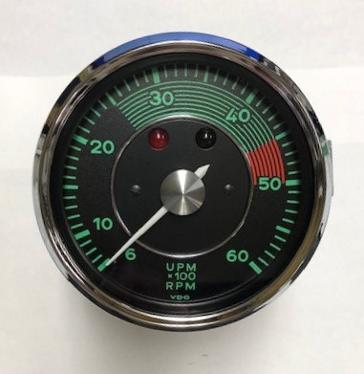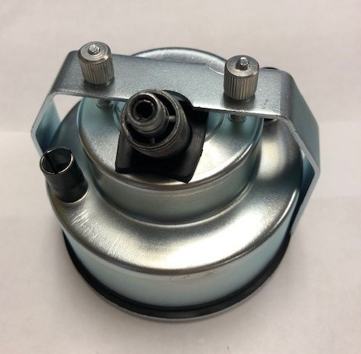
    - New lens’ will be applied, new face, new pointers, new screws, nuts, and bolts (all zinc’d), cleaned or new odometer wheels, new inlay rings, new bezel (chrome, black, or custom color if you desire), new bulbs, new rubber, and fresh glass.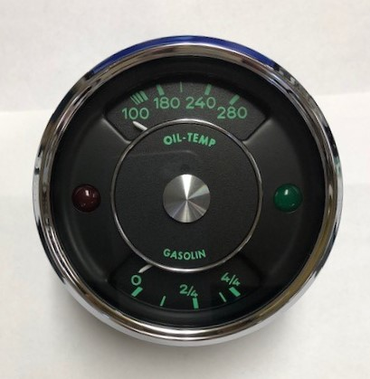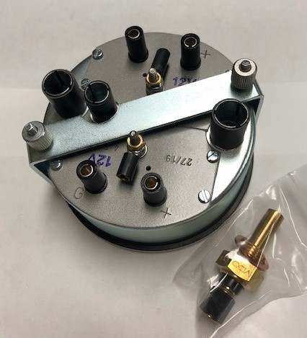
  + This job also has specific options that can be tailored however you like just let us know!
* **Refresh or Facelift**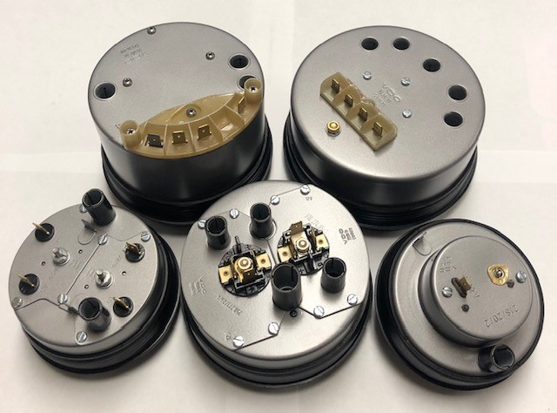
  + This job is where everything you see once the gauges are in the car is brand new.
    - For example, new gauge faces, pointers, lens, bezel, chrome cap, glass, inlay rings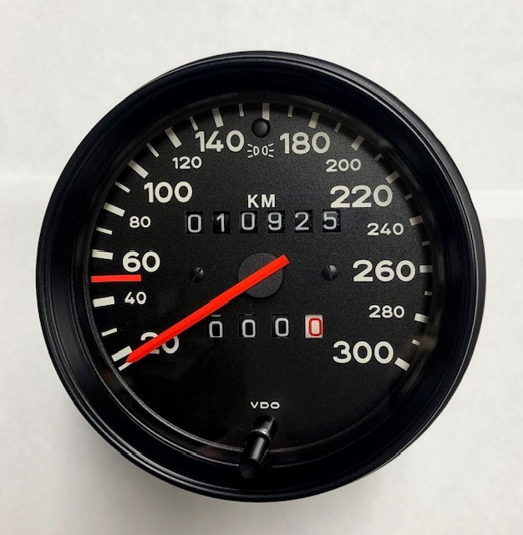
    - The case can be blasted and clear coated to prevent rust and add protection while keeping that OEM look. The case can also be left completely alone.
* **Specialty**